**BASIC DETAILS**

***NA*ME- RINKI ADHIKARI**

**DATE OF BIRTH- 13/03/1995**

**TIME OF BIRTH- 6.30 AM**

**PLACE OF BIRTH- KONTA**

**MARITAL STATUS- UNMARRIED**

**GOTRA- KASHYAP**

**GON- DEB**

**SUBCASTE- KAYASTHA**

**PRESENT CITY - SUKAMA**

**HEIGHT - 5.2F**

**BODY TYPE - AVARAGE**

**COMPLEXION - FAIR**

**EATING HABITS - NON VEG**

**DISABILITY- NO**

**ZODIAC- CANCER**

**MAGLIK- NO**

**EDUCATION AND OCCUPATIONAL –**

**EDUCATION - BA, B.ED**

**OCCUPATION- NOT WORKING**

**FAMILY DETAILS-**

**FATHER'S NAME - LATE SHREE PARIMAL CHANDRA ADHIKARI**

**OCCUPATION - GOVT SERVANT**

**MOTHER'S NAME - SMT USHA ADHIKARI**

**OCCUPATION - HOUSE WIFE**

**SIBLINGS- 2 BROTHERS AND 1 SISTER**

**ADDRESS- KONTA DISTRICT SUKMA CHHATTISGARH**

**ADDRESS** **AMBEDKAR COLONY KONTA DISTRICT SUKMA CHHATTISGARH**

**CONTACT NO. – 8103096985, 8103096985 9479869715**

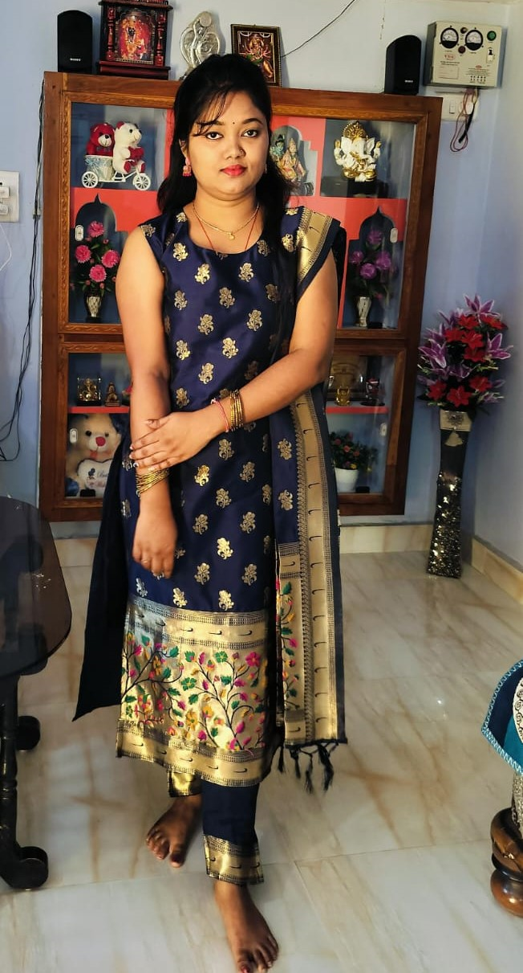

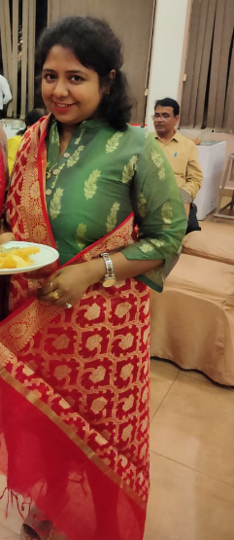

**BASIC DETAILS**

***NA*ME- DR. CHIDAKSHA KAR**

**DATE OF BIRTH- 10/05/1990**

**TIME OF BIRTH- 12:38 PM**

**PLACE OF BIRTH- RAIGARH**

**MARITAL STATUS- UNMARRIED**

**GOTRA- KASHYAP**

**GON- RAKOSHGON**

**SUBCASTE- KAYASTHA**

**PRESENT CITY - RAIPUR**

**HEIGHT - 5.1**

**COMPLEXION - DUSKY**

**EATING HABITS - NON-VEGETARIAN**

**DISABILITY- NO**

**ZODIAC- SCORPIONS**

**MAGLIK- YES**

**EDUCATION AND OCCUPATIONAL –**

**EDUCATION - MD PHARMACOLOGY (ONGOING)**

**OCCUPATION- GOVT MD PHARMACOLOGY 2ND YEAR**

**PACKAGE- 7 -8 LAKHS**

**FAMILY DETAILS-**

**FATHER'S NAME - LATE BISHWAJIT KAR**

**OCCUPATION - RETIRED BRANCH MANAGER SBI**

**MOTHER'S NAME - SHANTA KAR**

**OCCUPATION - HOUSE MAKER**

**SIBLINGS- 1 BROTHER (YOUNGER)**

**ADDRESS- RAIPUR**

**CONTACT NO. – 8349525630, 8717889992**



**BASIC DETAILS**

***NA*ME- MEGHA ROY CHOUDHARY**

**DATE OF BIRTH- 17/11/1995**

**TIME OF BIRTH- 9.10 PM**

**PLACE OF BIRTH- BHILAI**

**MARITAL STATUS- UNMARRIED**

**GOTRA- GAUTAM**

**GON- NARGON**

**SUBCASTE- KAYASTHA**

**PRESENT CITY - KHURSIPAR BHILAI**

**HEIGHT - 5.5**

**COMPLEXION - FAIR**

**EATING HABITS - NON-VEGETARIAN**

**DISABILITY- NO**

**ZODIAC- PIECES**

**MAGLIK- NO**

**EDUCATION AND OCCUPATIONAL –**

**EDUCATION - GRADUATION**

**OCCUPATION- PVT JAIKA AUTOMOBILE PVT.LTD.**

**FAMILY DETAILS-**

**FATHER'S NAME - P.C. ROY CHOUDHARY**

**OCCUPATION - RETIRED**

**MOTHER'S NAME - LT. CHITRA ROY CHOUDHARY**

**OCCUPATION - HOUSE WIFE**

**SIBLINGS- 1 ELDER BROTHER**

**ADDRESS- KHURSIPAR BHILAI**

**ADDRESS- BANGALI COLONY, NEW KHURSIPAR BHILAI**

**CONTACT NO. – 8103545685**

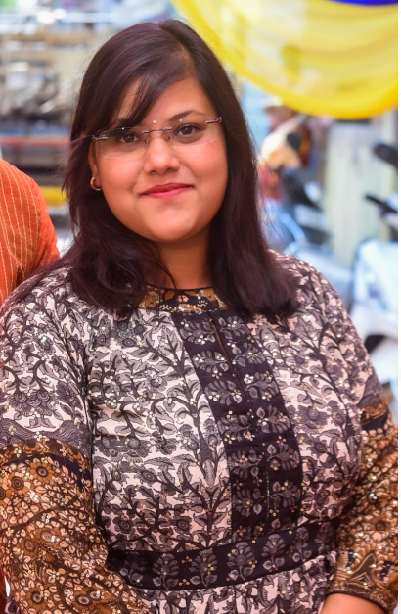



**BASIC DETAILS**

***NA*ME- NIDHI BOSE**

**DATE OF BIRTH- 24/06/1989**

**TIME OF BIRTH- 5.45PM**

**PLACE OF BIRTH- TIKAMGARH (M.P.)**

**MARITAL STATUS- UNMARRIED**

**GOTRA- KASHYAP**

**GON- RAKOSHGON**

**SUBCASTE- NAMASHUDRA**

**PRESENT CITY - SAGAR (M.P.)**

**HEIGHT - 5.2**

**COMPLEXION - WHEATISH**

**EATING HABITS - NON-VEGETARIAN**

**DISABILITY- NO**

**ZODIAC- AQUARIUS**

**MAGLIK- NO**

**EDUCATION AND OCCUPATIONAL –**

**EDUCATION - GRADUATE**

**OCCUPATION- GOVT. COMMUNITY HEALTH OFFICER**

**PACKAGE- 4-5 LPA**

**FAMILY DETAILS-**

**FATHER'S NAME - PRANAV KUMAR BOSE**

**OCCUPATION - SELF EMPLOYED**

**MOTHER'S NAME - RENU BALA BOSE**

**OCCUPATION - GOVT EMPLOYEE**

**SIBLINGS- ELDER 2 BROTHERS**

**ADDRESS- SHAHGARH, DISTRICT- SAGAR (M.P.)**

**ADDRESS- COMMUNITY HEALTH CENTER, WARD NO-15, SHAHGARH, DISTRICT- SAGAR (M.P.)**

**CONTACT NO. – 9036218497, 9691269384**

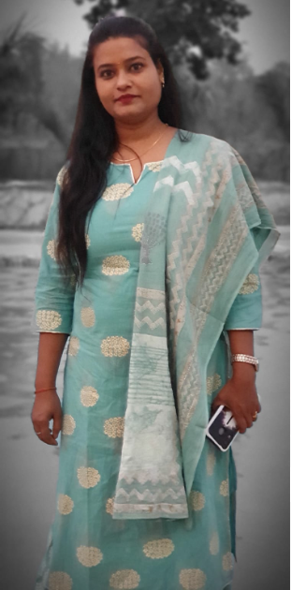

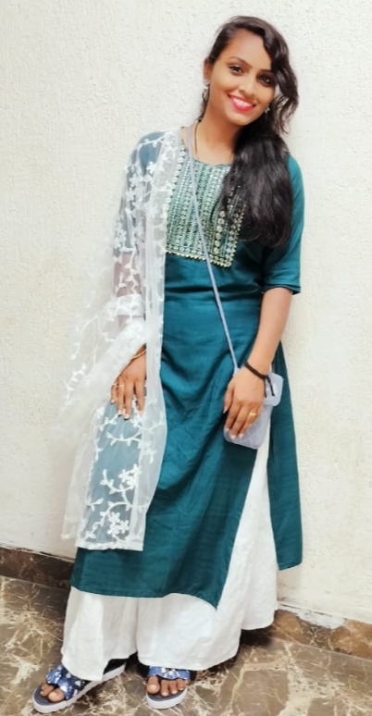

**BASIC DETAILS**

**NAME- BASANTI MANDAL**

**D.O.B - 4 APRIL 1996**

**PLACE - HARIDWAR**

**MERITAL STATUS – DIVORCEE**

**HEIGHT - 5 FT**

**COLOR COMPLEXION- DUSKY**

**BLOOD GROUP - B POSITIVE**

**RELIGION - HINDU**

**MANGALIK- NO**

**MOTHER TONGUE- BENGALI**

**CAST- NAMOSUDRA**

**GOTRA- KASHYAP**

**GAN - RAKASH**

**RASHI - MESH**

**EDUCATION AND OCCUPATIONAL –**

**QUALIFICATION: - GRADUATION COMPLETE WITH B.COM**

**OCCUPATION- NOT WORKING**

**FAMILY DETAILS-**

**FATHER NAME- LATE MR.UTTAM MANDAL**

**OCCUPATION- FARMER**

**MOTHER NAME- MRS. YASHODA MANDAL**

**BROTHER - 2 ELDER BROTHERS**

**ADRESSS- OWN HOUSE DAAS PARA DHARAMJAIGARH COLONY, JILA - RAIGARH**

**MOBILE NO- 9068321818**

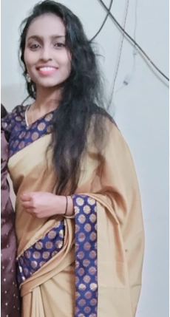

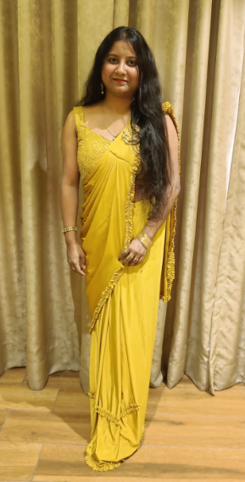

**BASIC DETAILS**

***NA*ME- ANKITA DAS**

**DATE OF BIRTH- 5/10/1995**

**TIME OF BIRTH- 09.30pm**

**PLACE OF BIRTH- BACHELI**

**MARITAL STATUS- UNMARRIED**

**GOTRA- ALIMBAN**

**GON- RAKSHAS**

**SUBCASTE- KAYASTHA**

**PRESENT CITY - HYDERABAD**

**HEIGHT - 5.2**

**COMPLEXION - FAIR**

**EATING HABITS - NON-VEG**

**DISABILITY- NO**

**ZODIAC-**

**MAGLIK- NO**

**EDUCATION AND OCCUPATIONAL –**

**EDUCATION - B.E (IT)**

**OCCUPATION- SOFTWARE ENGINEER (CAPGEMINI)**

**PACKAGE- 10-12 LPA**

**FAMILY DETAILS-**

**FATHER'S NAME - NITYANAND DAS**

**OCCUPATION - RETD. PRINICIPAL**

**MOTHER'S NAME - JAMUNA DAS**

**OCCUPATION - HOUSEWIFE**

**SIBLINGS- 1 ELDER BROTHER (UNMARRIED)**

**ADDRESS- H.NO. 210 WARD NO. 1 SUBHASH NAGAR, KIRANDUL**

**ADDRESS- CHHATTISGARH, ODISHA**

**CONTACT NO. – 8349048329, 9424278329**

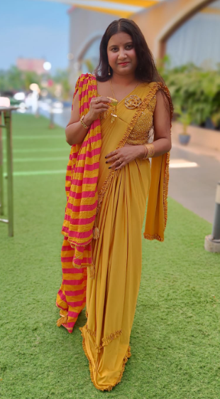

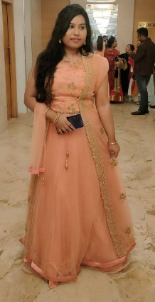

**BASIC DETAILS**

**NAME: SUPRIYA BAWALI**

**DATE OF BIRTH: 14.04.1994**

**TIME: 3.15 PM, TUESDAY**

**RASHI: DHANU**

**HEIGHT: 5'4"**

**EDUCATION AND OCCUPATIONAL –**

**QUALIFICATION: - M TECH. IN COMPUTER SCIENCE,**

**BE IN INFORMATION TECHNOLOGY**

**WORK: WORKING AS A SOFTWARE DEVELOPER AT OMNEPRESENT. PVT.LTD. PUNE. (CURRENTLY WFH).**

**FAMILY DETAILS-**

**FATHER: RETD. AAO FROM CENTRAL GOVT. OFFICE.**

**MOTHER: HOUSEWIFE**

**SIBLING: ONE ELDER BROTHER**

**PERMANENT ADD: RAIPUR (C.G)**

**MOB NO. 9425507948**

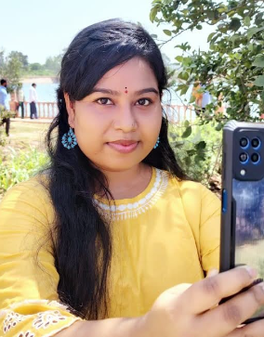

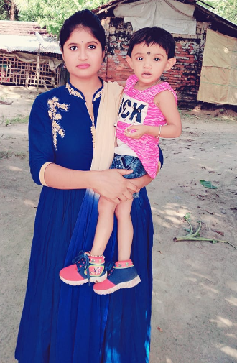

**BASIC DETAILS**

***NA*ME- SUNANDA MISTRI**

**DATE OF BIRTH- 28/12/1999**

**TIME OF BIRTH- 2.30 PM**

**PLACE OF BIRTH- BENGA WB**

**GOTRA- KASHYAP**

**GON- NOR**

**SUBCASTE- NOMO**

**PRESENT CITY - BHATAPARA**

**HEIGHT - 5.3**

**COMPLEXION - FAIR**

**EATING HABITS - NON VEG**

**DISABILITY- NO**

**ZODIAC- NOT MAINTIONED**

**MAGLIK- NO**

**EDUCATION AND OCCUPATIONAL –**

**EDUCATION - B.A., DCA**

**OCCUPATION- NOT WORKING**

**FAMILY DETAILS-**

**FATHER'S NAME - KRISHNA PADA MISTRY**

**OCCUPATION - PVT JOB**

**MOTHER'S NAME - KALPANA MISTRY**

**OCCUPATION - HOME MAKER**

**SIBLINGS- 1 ELDER BROTHER (UNMARRIED)**

**ADDRESS- BHATAPARA RAIPUR**

**NOTE- THEY ARE ACCEPTED UNMARRIED, DEVORCEE & WIDOWER ALSO, THEY PREFERED GODO FAMILY BACKGROUND.**

**ADDRESS- BHATAPARA RAIPUR**

**CONTACT NO. – 9926174391**

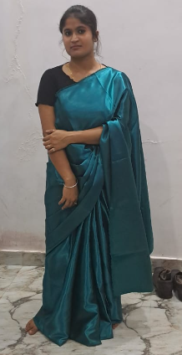

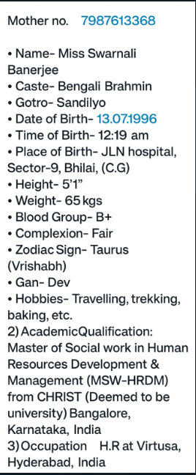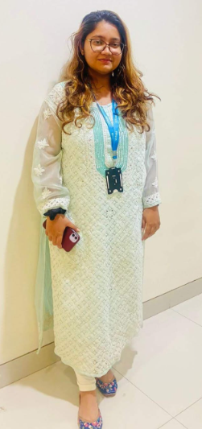

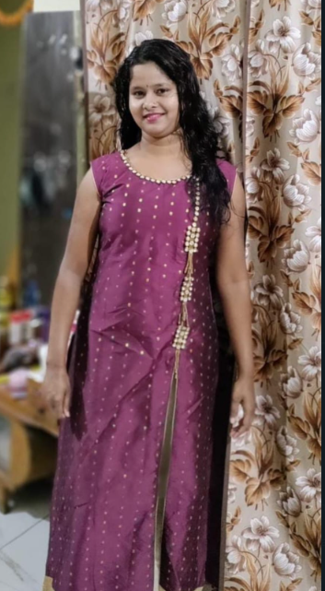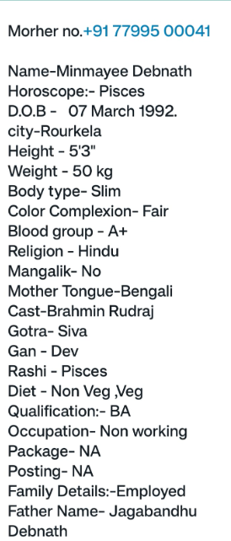

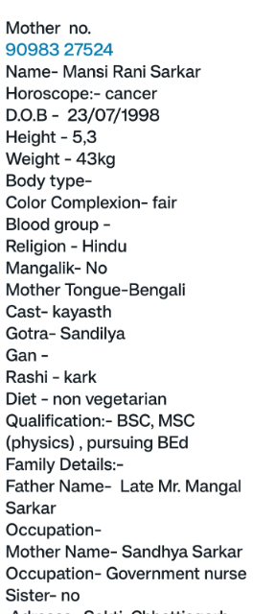

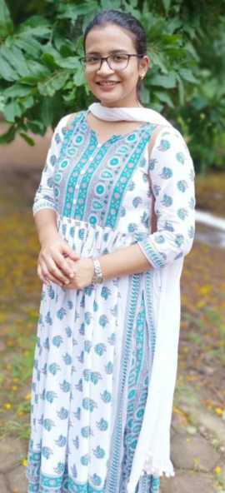

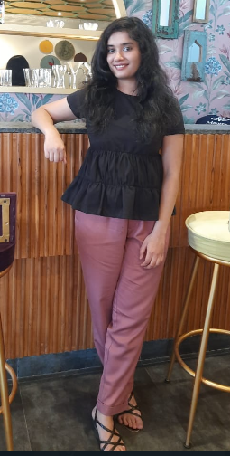

BIODATA of my daughter

Name- Anushka Ganguly

Father-Pradeep Ganguly

Mother-Susmita Ganguly (govt.teacher)

DOB 31/03/1998

Qualification- M.Sc.(chemistry) B.Ed.appearing.(Jodhpur)

Sibling - one elder brother working at Jaipur.

Height 5.3ft

Cast- Brahmin

Gotra- Shavorna

Complexion -Fair

We are looking for a boyof age 28-30 year,good looking and from bengali Brahmin family.Residence of Rajasthan is preferred.

Contact no. 9413772542

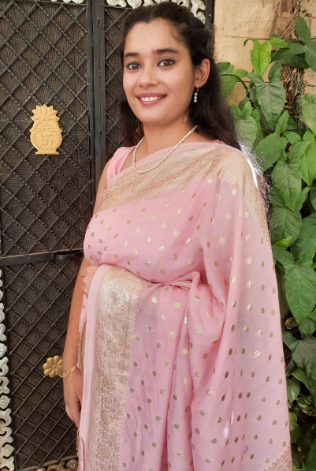

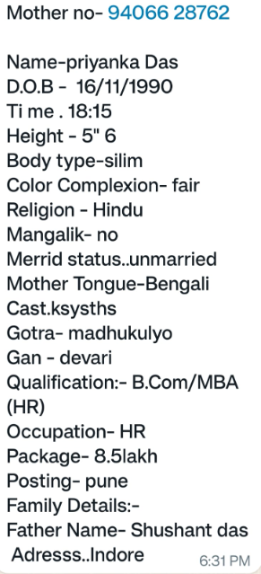

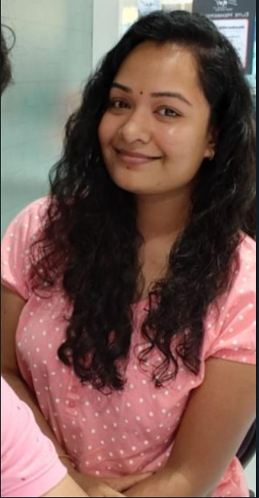

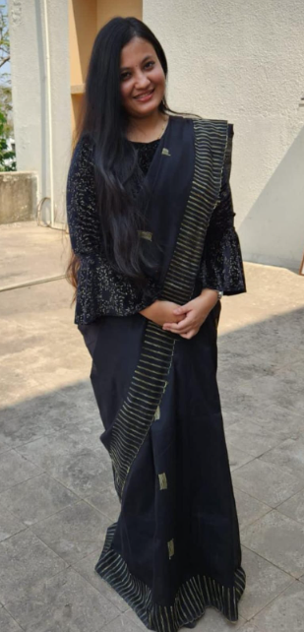

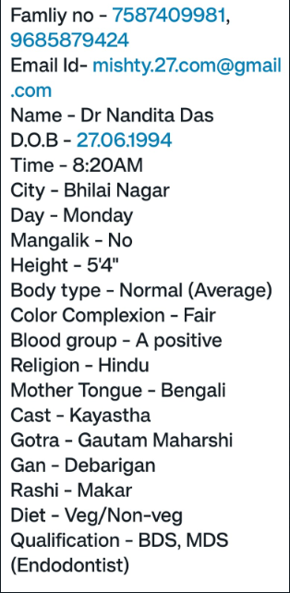

**BASIC DETAILS**

***NA*ME- MOUSHMI DASGUPTA**

**DATE OF BIRTH- 23/02/1998**

**TIME OF BIRTH- 06.46 AM**

**MARITAL STATUS- NEVER MARRIED**

**PLACE OF BIRTH- RAIPUR**

**GOTRA- MADHUGALLI**

**GON- NORGON**

**SUBCASTE- KAYASTHA**

**PRESENT CITY - RAIPUR**

**HEIGHT - 5F-152CM**

**COMPLEXION - WHEATISH**

**EATING HABITS - NON-VEG**

**DISABILITY- NO**

**EDUCATION AND OCCUPATIONAL –**

**EDUCATION - M.SC., B.ED.**

**OCCUPATION- PVT. TEACHER**

**FAMILY DETAILS-**

**FATHER'S NAME - SHRI DEVBRAT DASGUPTA**

**OCCUPATION - EMPLOYED**

**MOTHER'S NAME - SMT. SUMITA DASGUPTA**

**OCCUPATION - PVT. TEACHER**

**SIBLINGS- 1 ELDER BROTHER (UNMARRIED)**

**ADDRESS- GUDHIYARI RAIPUR**



**BASIC DETAILS**

***NA*ME- LINA BISWAS**

**DATE OF BIRTH- 07/07/1986**

**TIME OF BIRTH- EVENING**

**PLACE OF BIRTH- PILIBHIT**

**MARITAL STATUS- NEVER MARRIED**

**GOTRA- KASHYAP**

**GON- DEVGON**

**SUBCASTE- NAMASHUDRA**

**PRESENT CITY - PILIBHIT**

**HEIGHT - 5.3F**

**COMPLEXION - FAIR**

**EATING HABITS - NON-VEGETARIAN**

**DISABILITY- NO**

**ZODIAC- ARIES**

**MAGLIK- DON'T KNOW**

**EDUCATION AND OCCUPATIONAL –**

**EDUCATION - B.ED.**

**OCCUPATION- NOT WORKING**

**FAMILY DETAILS-**

**FATHER'S NAME - AMULLYA BISWAS**

**OCCUPATION - FARMER**

**MOTHER'S NAME - SAVITRI BISWAS**

**OCCUPATION - HOME MAKER**

**SIBLINGS- 3 BROTHERS**

**ADDRESS- PILIBHIT (UTTAR PRADESH)**

**CONTACT NO. – 7406389607, biswasdec2012@gmail.com**

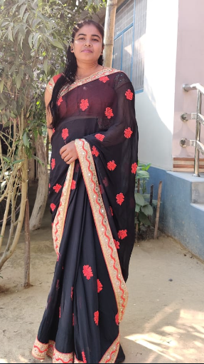

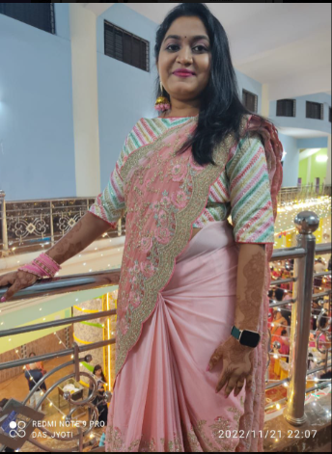

**BASIC DETAILS**

***NA*ME- SHWETA SARKAR**

**DATE OF BIRTH- 19-01-1989**

**TIME OF BIRTH- ------**

**PLACE OF BIRTH- KIRANDUL, CG**

**MARITAL STATUS- NEVER MARRIED**

**GOTRA- KASHYAP**

**SUBCASTE- NAMOSUDRA**

**HEIGHT - 5.3’’**

**COMPLEXION - FAIR**

**EATING HABITS - NON VEG**

**EDUCATION AND OCCUPATIONAL –**

**EDUCATION - COMPLETED GNM, MA (SOCIALOGY),**

**OCCUPATION- STAFF NURSE**

**FAMILY DETAILS-**

**FATHER'S NAME - MR.RATAN SARKAR**

**OCCUPATION - PVT JOB**

**MOTHER'S NAME - MRS. CHAYA SARKAR**

**OCCUPATION - HOUSEWIFE**

**SIBLINGS- 2 BROTHER 1SISTER BOTH THE BROTHERS ARE WORKING IN PVT COMPANY 1SISTER -MARRIED**

**ADDRESS- OLD BHATTIPARA WARD NO-07**

**CONTACT NO. – 9479006477, 7587001129**